(A) Maven Outputs
    - First run Maven clean.
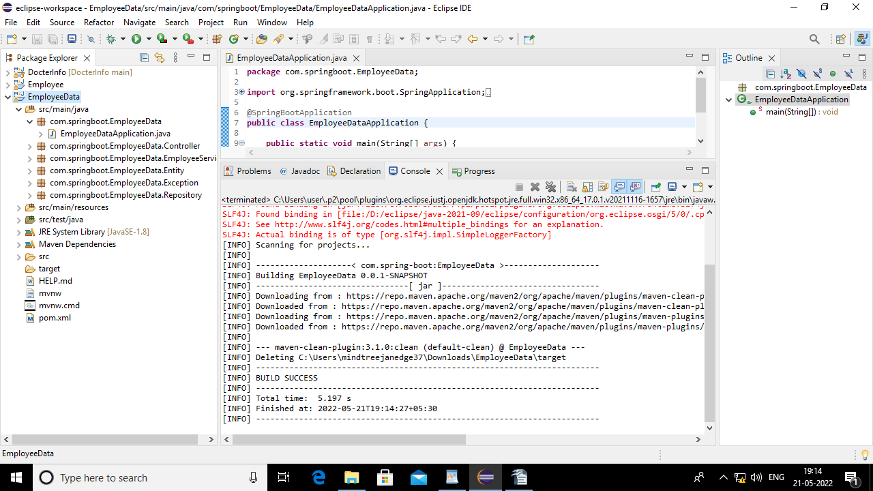

2.Maven build and put goal as “package”.
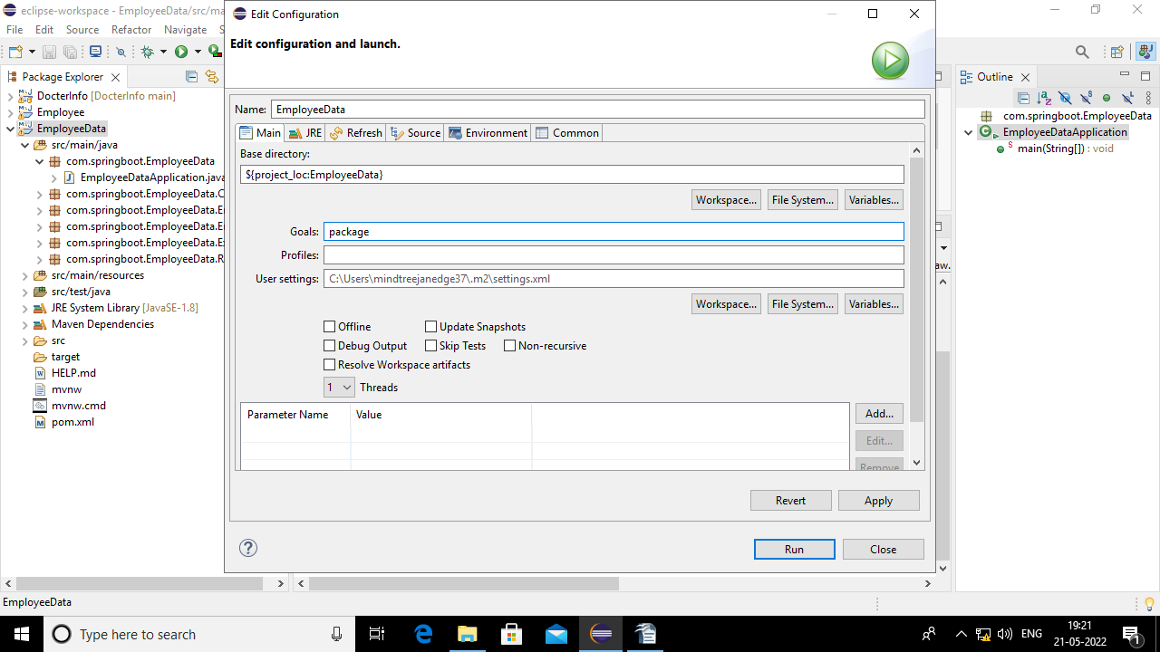

    - Output of package.
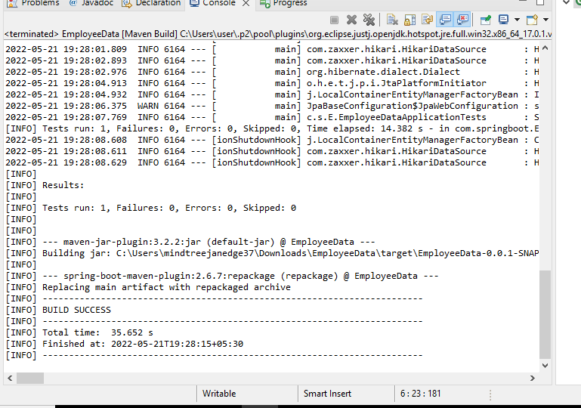
- Generated jar file under target folder.

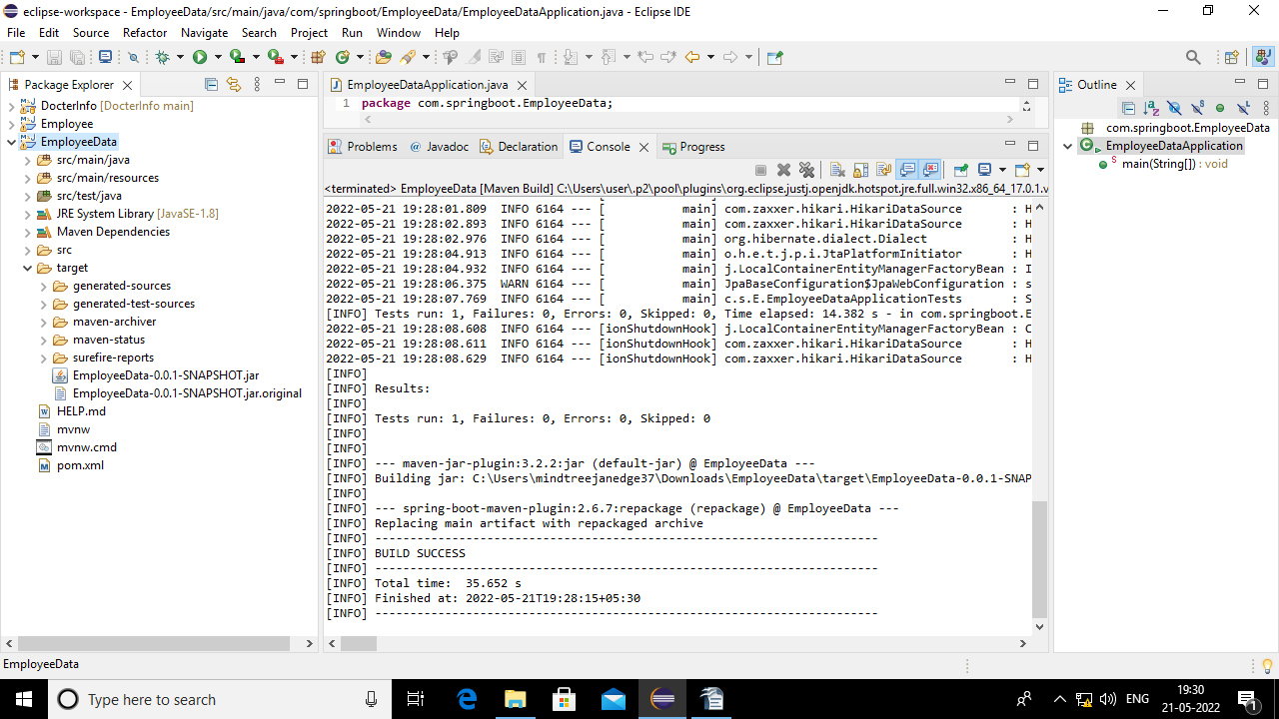

(B) Git And GitHub Outputs.

    - Create a empty git repository in github
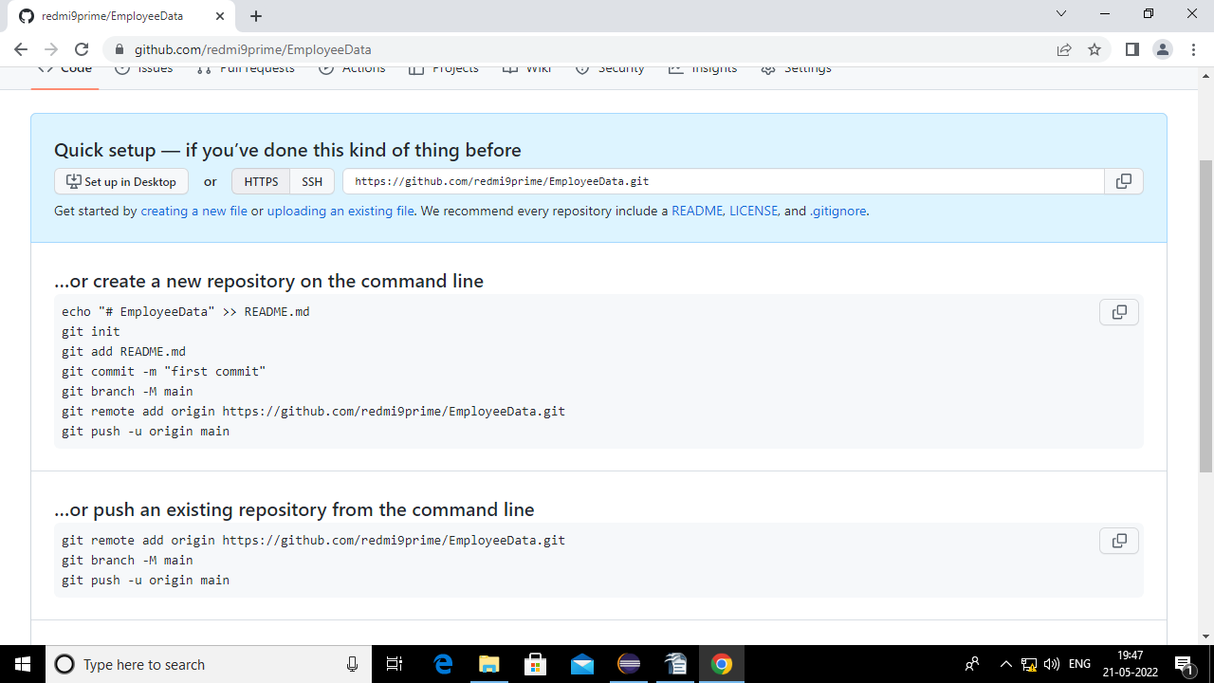

2.Then follow the below commands
a) git init in the repository on your local system.
b) git add -A
c) git commit -m “message”
d) git add remote origin “url”
e)git push -u origin master //-u refers to upstream

- github Repository
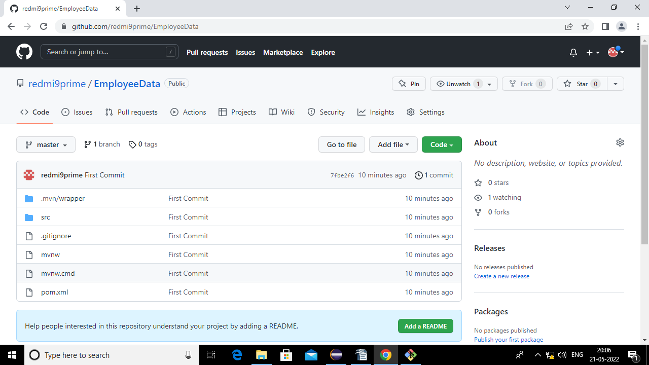

- jenkins Outputs
- Open jenkins select new item and then select pipeline and write name for pipeline.
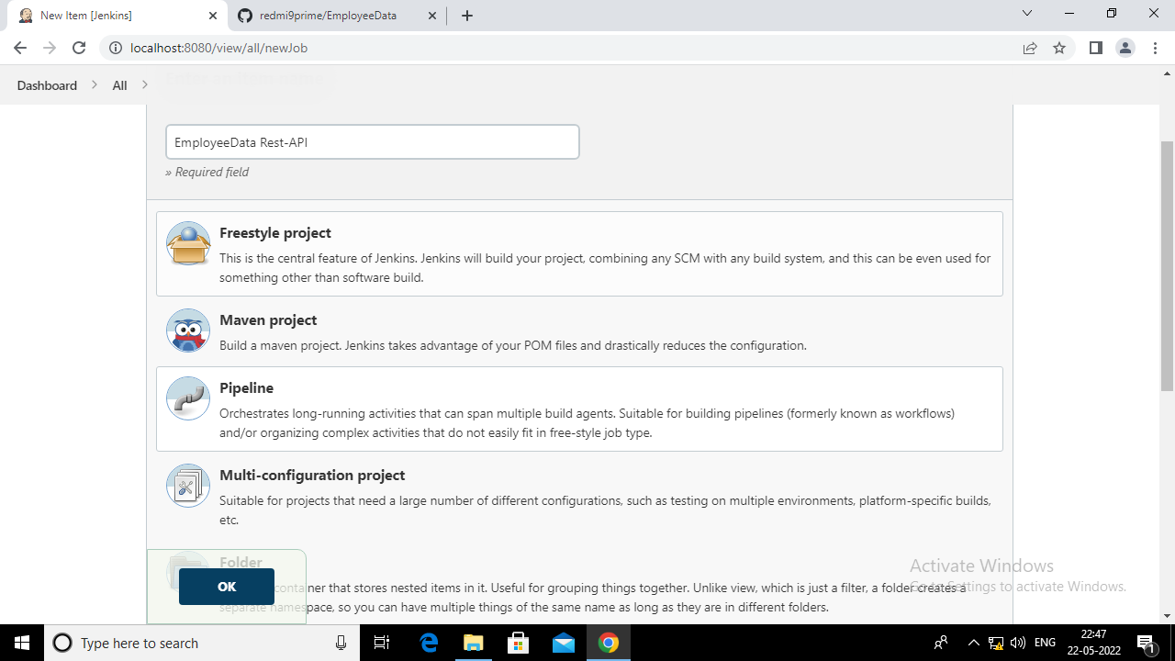

- Then select github project and paste the url of the project pushed to github.
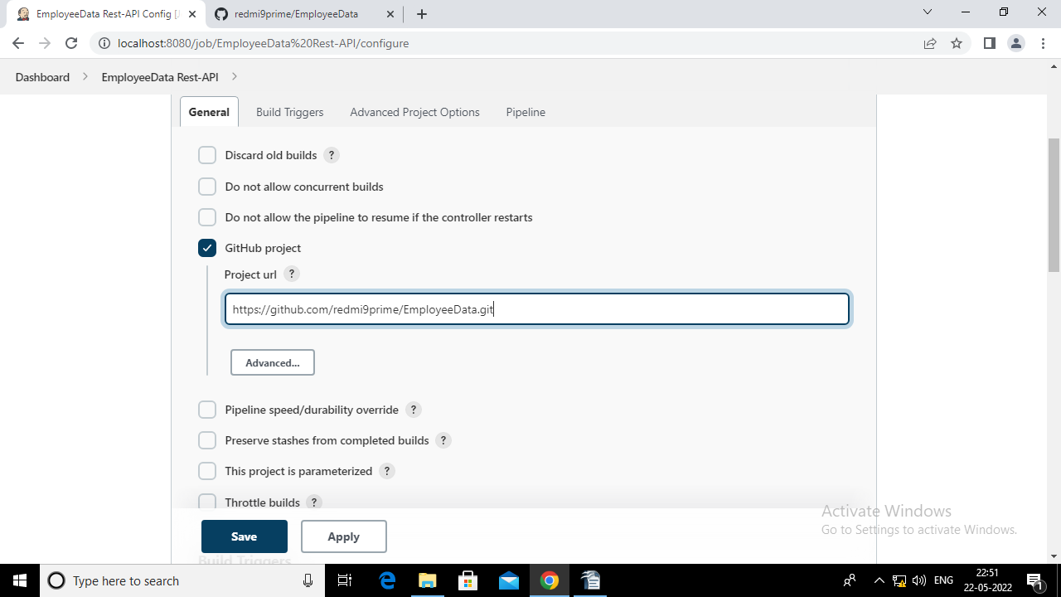
- Then select Build whenever a SNAPSHOT dependency is built and GitHub hook trigger for GITScm polling.
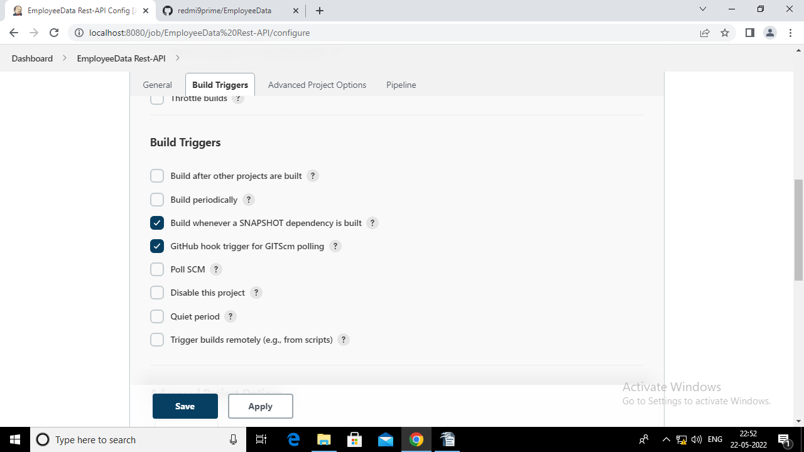

- Then write the script for pipeline.
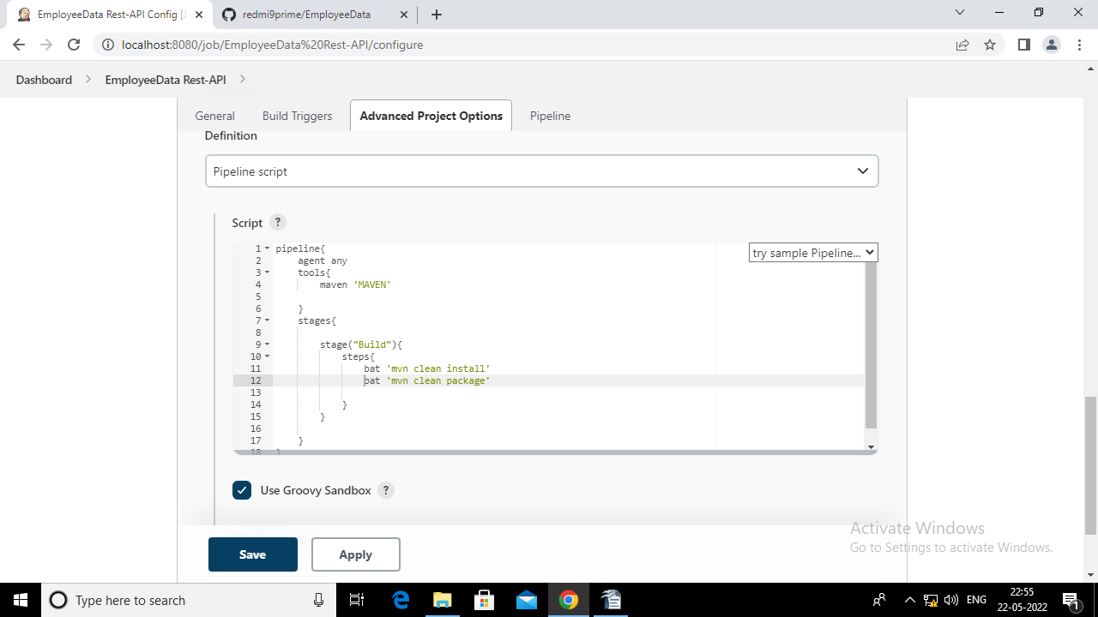

- After clicking on “build now” pipeline will appear
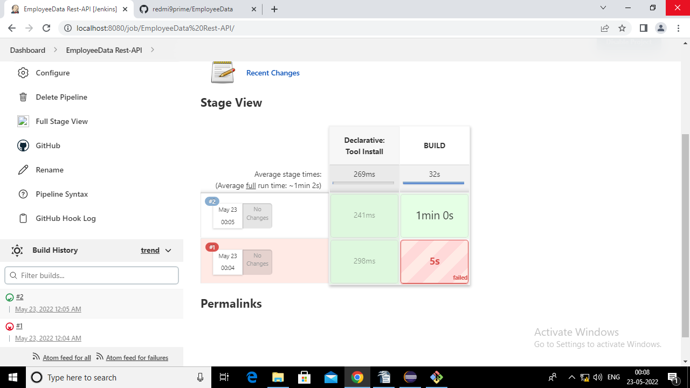

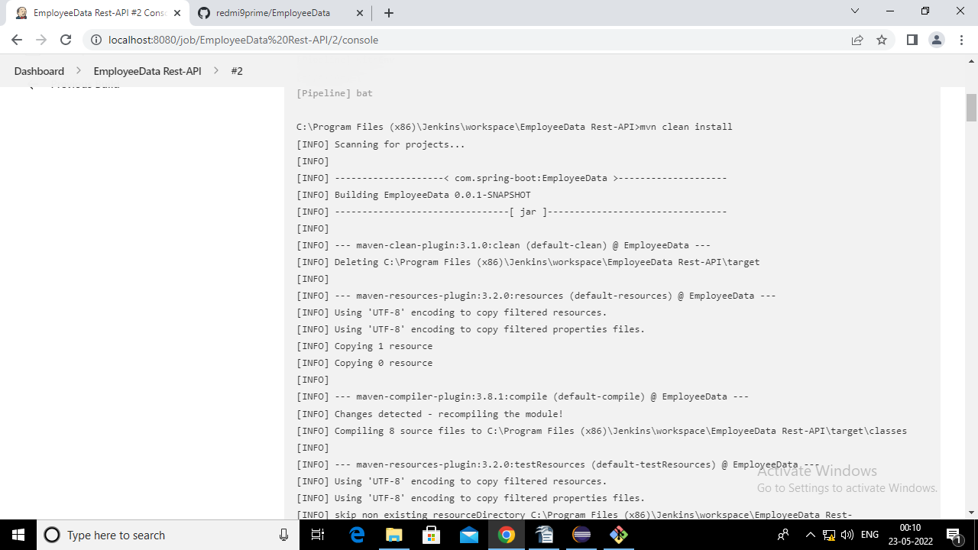

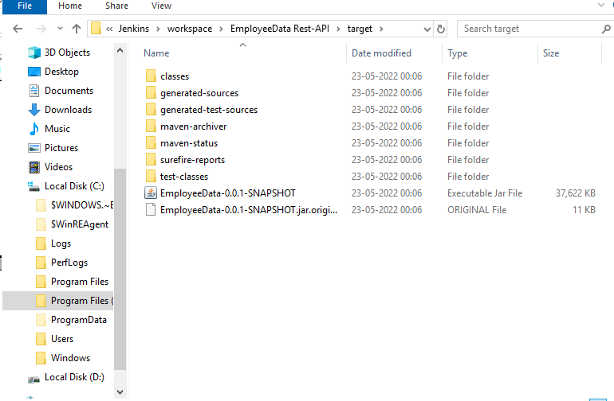

                - Docker Outputs

- Create a Dockerfile in eclipse editor in that project.
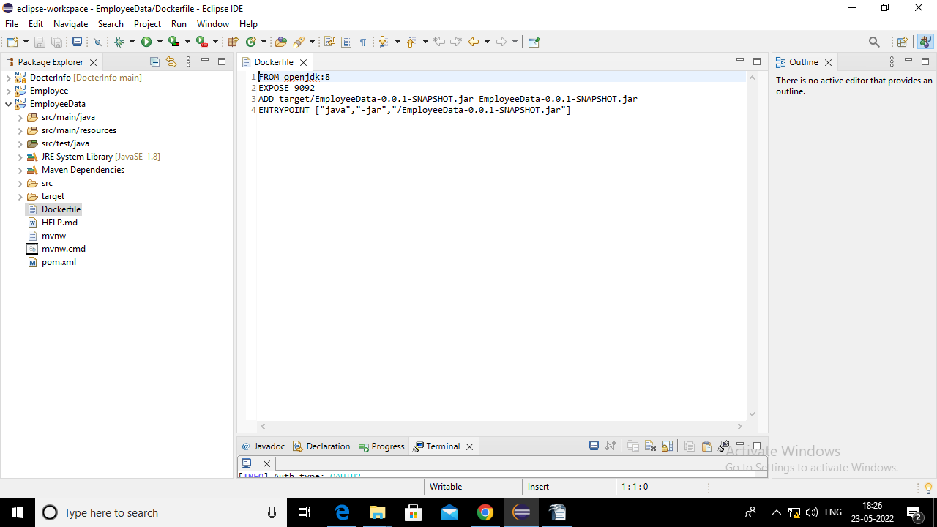

2. Save the changes and push it to github.
3. then run the docker build command
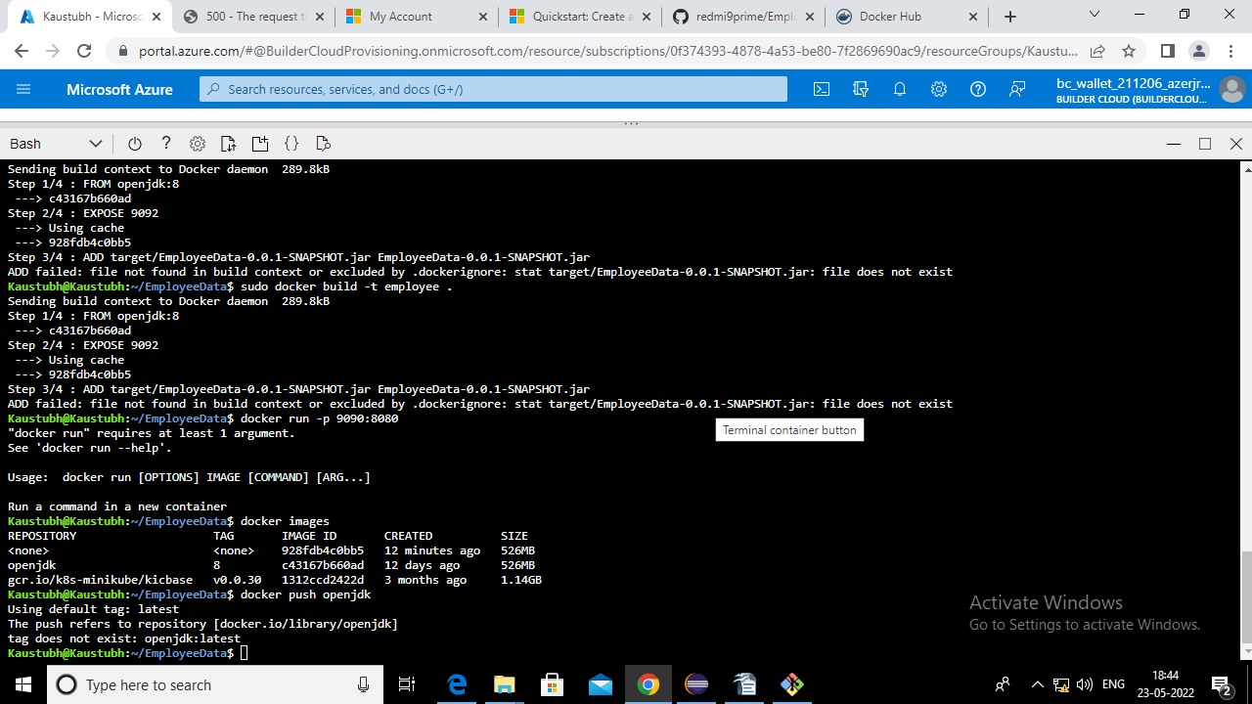
4. then docker push

